

Northleaze C of E Primary School
‘Let your light shine.’ (Matthew 5:16)
Pupil Premium Strategy Statement 2021 - 2024

This statement details our school’s use of pupil premium (and recovery premium for the 2024 - 2025 academic year) funding to help improve the attainment of our disadvantaged pupils.

It outlines our pupil premium strategy, how we intend to spend the funding in this academic year and the effect that last year’s spending of pupil premium had within our school.

School overview
Detail | Data
School name | Northleaze C of E Primary School
Number of pupils in school | 181
Proportion (%) of pupil premium eligible pupils | 1.7%
Service pupils | 7.2%
Academic year/years that our current pupil premium strategy plan covers | 2021/2022 to  2024/2025
Date this statement was published | December 2021
Date this statement was updated | December 2024
Date on which it will be reviewed | December 2025
Statement authorised by | Jenny Campbell
Pupil premium lead | Joe Thompson
Governor / Trustee lead | John Davies/Claire Pringle

Funding overview
Detail | Amount
Pupil premium funding allocation this academic year | £5,530
Service pupil premium funding | £4,420
Pupil premium funding carried forward from previous years (enter £0 if not applicable) | £0
Total budget for this academic year  (If your school is an academy in a trust that pools this funding, state the amount available to your school this academic year.) | £9,950

Part A: Pupil premium strategy plan

Statement of intent
Improving the outcomes, and therefore life chances and choices, of our disadvantaged pupils is a key priority for both Northleaze School and our Trust (Lighthouse Schools Partnership). We work towards achieving the Trust Strategic Plan and these objectives form a key part of our School Development Plan each year.
The Trust Disadvantaged Strategy draws on evidence and research from the EEF and current advice and best practice as outlined by Marc Rowland (2021) in his book ‘Addressing Educational Disadvantage in schools and colleges’ to develop its policy. As a school, we have developed our Disadvantaged Strategy to build on these principles, aiming to ensure that the needs of all disadvantaged pupils are met effectively so that the attainment and progress gaps between disadvantaged and non-disadvantaged students and pupils closes. The strategy, whilst specifically aimed at improving the educational provision and outcomes for disadvantaged pupils, should also positively impact progress and education of all learners within our school.
The Trust has a responsibility to support and challenge its schools in ensuring that pupils identified as being at risk of underachieving due to disadvantage have the same opportunities as other pupils to achieve and therefore succeed. The Trust believes the most effective way to ensure equal opportunities for all is to remove the barriers to underachievement for identified pupils at the earliest possible opportunity. The recent report by the Education Endowment Fund (EFF) entitled ‘EEF Guide to the Pupil Premium 2019 (updated in 2023)’, as well as the EFF report entitled ‘The Attainment Gap 2017’; and the previous joint report between the EEF and the Sutton Trust entitled ‘Pupil Premium: The Next Steps (2015)’ all refer to the fact that the most effective learning opportunities for pupils, who are disadvantaged, are those that are based on early identification, high quality teaching, employment of proven and research based interventions which accelerate progress early on and, importantly, learning that is tied in with ‘memorable experiences’.
The Education Endowment Foundation has identified a tiered approach (good practice) to spending for pupils identified as disadvantaged:
High quality teaching for all – Spending on improving teaching might include professional development, training and support for early career teachers, coaching and mentoring for all teachers, and recruitment and retention. Ensuring an effective teacher is in front of every class, and that every teacher is supported to keep improving, is the key ingredient of a successful school and should rightly be the top priority for pupil premium spending.
Targeted academic support - Evidence consistently shows the positive impact that targeted academic support can have, including on those who are not making good progress across the spectrum of achievement. Considering how classroom teachers and teaching assistants can provide targeted academic support, including how to link structured one-to-one or small group intervention to classroom teaching, is likely to be a key component of an effective pupil premium strategy.
Wider strategies - Wider strategies relate to the most significant non-academic barriers to success in school, including attendance, behaviour, and social and emotional support. While many barriers may be common between schools, it is also likely that the specific features of the community each school serves will affect spending in this category.
Our aims for our disadvantaged pupils are to:
- Remove barriers to learning created by poverty, family circumstance and back-ground.
- Narrow the attainment gaps between disadvantaged pupils and their non-disadvantaged counterparts both within school and nationally.
- Ensure ALL pupils are able to read fluently and with good understanding to enable them to access the breadth of the curriculum.
- Enable pupils to look after their social and emotional wellbeing and to develop resilience.
- Allow pupils to access a wide range of opportunities to develop their knowledge and understanding of the world.

Challenges

This details the key challenges to achievement that we have identified among our disadvantaged pupils.
Challenge number | Detail of challenge
1 | Gaps in phonics, reading, writing or maths.
2 | Pupils well-being and social emotional, mental health including emotional self-regulation in order to be ready to learn.
3 | Access to wider opportunities.

Intended outcomes
This explains the outcomes we are aiming for by the end of our current strategy plan, and how we will measure whether they have been achieved.
Intended outcome (broader and measurable) | Success criteria
To close gaps in phonics, reading, writing or maths (Depending on individual need) | - The attainment of disadvantaged pupils is at least in line with that of their non-disadvantaged peers.  - NFER and SATS scaled scores improve through the year.  - Evidence of in class support and same day intervention to swiftly address misconceptions.  - Teachers’ planning indicates an understanding of the types of scaffolds required to enable all pupils (but particularly those with disadvantage) to attain well.  - Targeted 1:1 support to close identified gaps is in place and monitored robustly.
All disadvantaged pupils pass the phonics screening check in Year 1. | - The attainment of disadvantaged pupils is at least in line with that of their non-disadvantaged peers.  - Disadvantaged pupils demonstrate a love of reading (evidenced through pupil voice) and talk about books they have read.  - Timetabled 1:1 precision phonics interventions is in place.  - Robust tracking and monitoring of 1:1 phonics intervention takes place by the Phonics Lead.
Disadvantaged pupils at Northleaze have good social, emotional and mental health | - Children will have time to talk about their social, emotional and mental health in small groups with a trusted adult or ELSA.  - All mental health CPOMs reports are monitored and followed up by the mental health lead  - From January 2023, a member of staff will be a qualified ELSA and be working 1:1 with children.
For our disadvantaged pupils to have the equal access to wider opportunities | - All disadvantaged pupils will be able to go on residential visits and class trips  - For disadvantaged pupils to be offered the chance to learn a musical instrument or to attend a club.
Activity in this academic year

This details how we intend to spend our pupil premium this academic year to address the challenges listed above.

Teaching (for example, CPD, recruitment and retention)
Budgeted cost: 3,000
Activity | Evidence that supports this approach | Challenge number(s) addressed
EYFS, KS1 and LKS2 phonics training including SSP lowest 20% intervention training for teachers and support staff  £1000 | Using the Unlocking Letters and Sounds Phonics Scheme consistently across the school  https://www.unlockinglettersandsounds.com/  DfE Reading Framework 2021 | 1
CPD to provide teachers with skills to deliver high quality teaching including White Rose Training.  £1600 |  | 1
Associate HT to complete safer recruitment training  £35 | NSPCC Safer Recruitment | 1,2, and 3
Completion of ‘One Page Profiles’ and ‘Provision Maps’ for all disadvantaged pupils. This should ensure that teachers and support staff have a full understanding of each pupil’s barriers to learning and can adapt teaching to meet their needs.  £365 | Marc Rowland – Addressing Educational Disadvantage in Schools | 1, 2 and 3
Targeted academic support (for example, tutoring, one-to-one support structured interventions)
Budgeted cost: £4500
Activity | Evidence that supports this approach | Challenge number(s) addressed
Additional (and some existing) hours of TA time to carry out targeted, evidenced based interventions  £1800 | ‘There is evidence that Teaching Assistants are more likely to have a positive impact when delivering structured interventions than as general classroom support.’  EEF Making Effective use of TAs | 1
One afternoon a week to support service and disadvantaged pupils in KS2 with targeted, 1:1 phonics and reading intervention.  £1100 | ‘There is evidence that Teaching Assistants are more likely to have a positive impact when delivering structured interventions than as general classroom support.’  EEF  https://educationendowmentfoundation.org.uk/projects-and-evaluation/projects/catch-up-numeracy | 1
One afternoon a week for our qualified ELSA to work with pupils who have been identified as having SEMH needs.  £1600 | https://www.elsanetwork.org/about/  It recognises that children learn better and are happier in school if their emotional needs are also addressed.  EEF: Improving Social and Emotional Learning in Primary Schools 2019 | 2

Wider strategies (for example, related to attendance, behaviour, wellbeing)
Budgeted cost: £2450
Activity | Evidence that supports this approach | Challenge number(s) addressed
Purchase high quality texts for disadvantaged pupils  £700 (£100 per class) | DfE Reading Framework 2021  ‘Making sure that children become engaged with reading from the beginning is one of the most important ways to make a difference to their life changes’ | 1
Pay for the costs of all trips, workshops, residential visits and a club per year for our disadvantaged pupils  £1500 | Evidence from EEF- Arts participation Aspiration interventions  Marc Rowland – Addressing Educational Disadvantage in Schools | 3
Nurture UK Toolboxes which support children with sensory needs, transition and wellbeing  £250 | Nurture UK | 2
Specific resources for Service pupils  Teachers will identify resources to support pastoral, SEMH or academic need for these pupils.  £1000 (resources)  £2800 (in class TA support) | Service Pupil Premium – DfE September 2021  ‘Schools (are best placed to) respond to the specific needs of those pupils for whom the funding has been allocated. The funding could be spent on providing a variety of means of support including counselling provision, nurture groups etc.’ | 1,2,3

Total budgeted cost: £9,950

Part B: Review of outcomes in the previous academic year

Pupil premium strategy outcomes
This details the impact that our pupil premium activity had on pupils in the 2022 to 2023 academic year.
Intended outcome (broader and measurable) | Success criteria | Impact
To close gaps in phonics, reading, writing or maths (Depending on individual need) | - attainment of disadvantaged pupils is in line or above that of their non-disadvantaged peers  - equal access to all areas of the curriculum due to improved numeracy and literacy skills  - evidenced in the end of year teacher assessment and/ or standardised scores from NFER results.  - teachers understand the types of scaffolds required and carefully plan which scaffolds will be best for pupils  - Timetabled 1:1 support evident. | - 100% of PP pupils maintained or exceeded their prior attainment in reading (91% for non-PP), 100% in writing (92% for non) and 100% in maths (95% for non)  - One PP child in Year 4 achieved a higher than average result in the summer NFER reading tests and an high average score in the summer NFER maths tests  - See tables below for overall attainment of PP pupils compared to non-PP pupils in reading, writing and maths  - One child in Year 3 who received targeted 1:1 support for reading, reached made more than expected progress in reading
For our disadvantaged pupils to pass the phonics screening check in Year 1 | - attainment of disadvantaged pupils is in line or above that of their non-disadvantaged peers  - for our disadvantaged pupils to have a love of reading and be able to talk about the books they have read.  - Timetabled 1:1 precision phonics support evident. | - All PP children have now passed the PSC. One child who failed it in Year 1 has now passed it in Spring 2024.  - High quality texts bought for each class to increase all pupils’ enjoyment of reading.  - Training for 1:1 phonics intervention provided for all support staff.  - In our latest Ofsted report (May 2022) this was noted as being strong practice:  ‘From early years to Year 6, there is a sharp focus on teaching ambitious vocabulary.’
For our disadvantaged pupils to have good social, emotional and mental health | - Children will have time to talk about their social, emotional and mental health in small groups with a trusted adult or ELSA.  - All mental health CPOMs reports are monitored and followed up by the mental health lead  - From January 2023, a member of staff will be a qualified ELSA and be working 1:1 with children.  - PP children are Boxall profiled again to monitor progress and ensure current strategies are impactful. | - Mental health concerns continue to be recorded on CPOMS and the mental health lead is alerted. Resources to support group sessions (e.g. ‘Time to Talk’) purchased and support staff time given.  - By Term 5 2024, the Mental Health and PSHE Leads will have created a flow chart to show support and signposting for particular mental health concerns.  - Attendance of disadvantaged pupils in 2023-24 is 97.2% compared with 97.1% (non-disadvantaged)  - Member of support staff now fully qualified ‘ELSA’ and working with identified pupils.
For our disadvantaged pupils to have the equal access to wider opportunities | - All disadvantaged pupils will be able to go on residential visits and class trips  - For disadvantaged pupils to be offered the chance to learn a musical instrument or attend a club.  - PP children and service children have priority to access additional enriching experiences that don’t include the whole class or school. | - All disadvantaged pupils in Year 5 and 6 attended residential visits alongside their peers (fully paid for).  - All disadvantaged pupils attended all class trips and visits (fully paid for).  - Disadvantaged pupils in KS2 attended after school clubs with Bristol Sport. Pupils offered the opportunity to learn an instrument.  - Three PP children attended the Wimbledon championships in 2024 as well as some service children
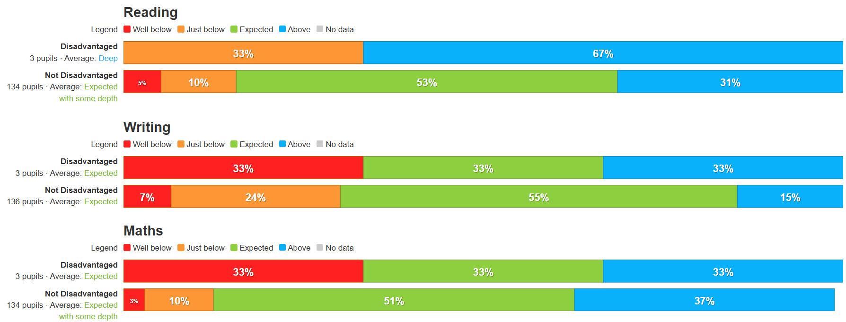

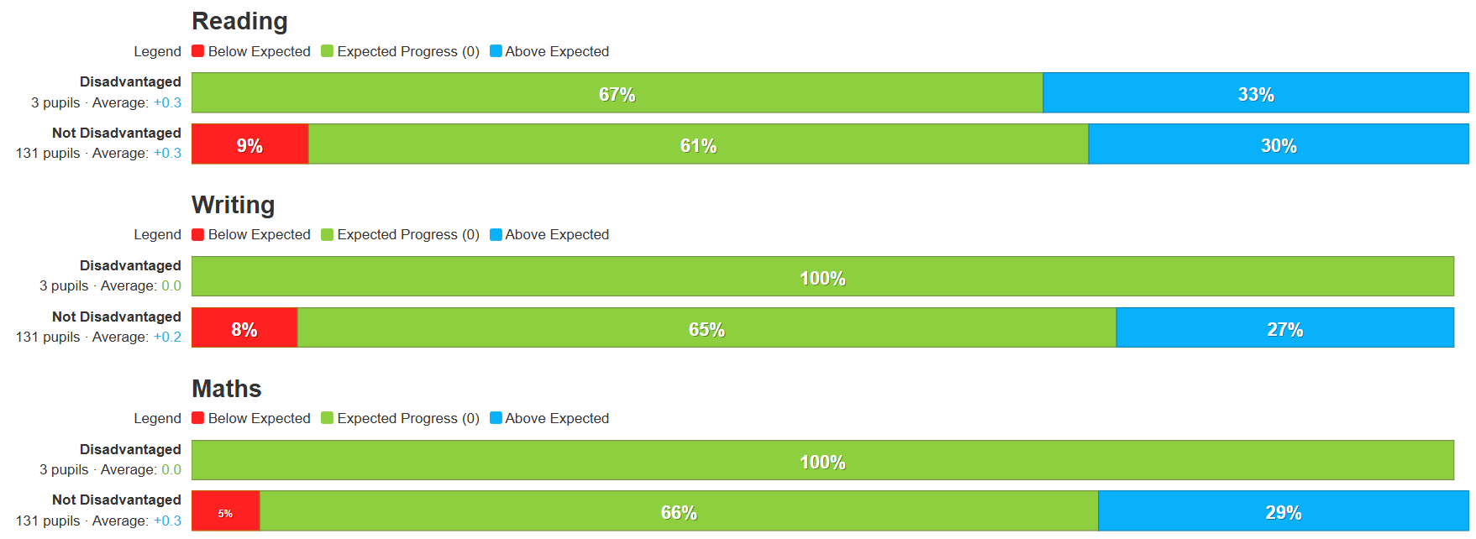

Externally provided programmes:
Programme | Provider
Jigsaw – PSHE from EYFS- Year 6 | Jigsaw
Sing Up | Singup.org
Charanga Music scheme | Charanga
PE Planning | PEPlanning.org.uk
ULS Phonics & Handwriting | Unlocking Letters and Sounds
Maths Curriculum, CPD and support | White Rose

Service pupil premium funding:
Measure | Details
How did you spend your service pupil premium allocation last academic year? | - Our Service pupils were included, where appropriate, in the support and opportunities mentioned above, for our disadvantaged pupils.  - We provided additional, targeted 1:1 support to enable gaps to be closed in pupils’ learning.  - We purchase resources to support: transition, language development and social and emotional need.  - Service children had the opportunity to attend significant sporting events
What was the impact of that spending on service pupil premium eligible pupils? | - 100% of Service pupils reached or exceeded the expected standard in reading at the end of last year (55% at greater depth).  - 91% of Service pupils reached or exceeded the expected standard in writing at the end of last year (18% greater depth).  - 100% of Service pupils reached or exceeded the expected standard in maths at the end of last year (36% greater depth).  - 100% of service children made at least expected progress from 2022-23 to 2023-24  - 33% of service children more than expected progress in reading  - 22% of service children made more than expected progress in writing  - 56% of service children made more than expected progress in maths
How do you plan to offer to support service pupil premium pupils this year? | - We will provide targeted 1:1 support for pupils where assessment indicate a gap in writing skills.  - We want to purchase materials which will specifically support individual pupils’ needs.  - Continue to provide opportunity to attend a significant experience for service children.

